Logbook

Weekly Report

1st Week Report
The first week was based on the discovery of our team. We had team building to get to know each other, find our identity by building a mascot, set rules in our team and choose a topics for our project. We tried to choose a subject that appeals to everyone and in agreement with our study. We think that The GreenHouse is a good topic for us.

2nd Week Report
In the second week, our subject has been validated which enabled us to begin the planning of our project (allocation tasks, Gantt). In a second time, we spent the week to search ideas and concept and we have agreed to create a greenhouse for aromatic plants. We have also chosen the target which allowed us to determine in what kind of environment The GreenHouse will have to integrate. This week has allowed us to have an overview of our project over time and to know more concretely what everyone has to do.

3rd Week Report
In the third week Antonio started with making the State Of Art with the help of Mathias. Mathias worked on the black box. Antonio and Cristina did the drawings. Cristina prepared the presentation about our project and group that we had to do that week for the communication course. Christophe and Alisson worked on the market analysis for the marketing plan. Christophe finished the introduction part of the report. Alisson worked on the Gantt to improve it. We also decided for which plant we will make The GreenHouse. For the Ethics course we prepared the first case in our group. Finally, we decided what our public would be.

4th Week Report
In this week, Alisson worked on the leaflet for the communication course, improved the Gantt and begun to write the project management part. Antonio finished the part of the state of the art. Antonio, Mathias and Cristina did the cardboard scale model and the drawings. Christophe started to search information for the ethic part and worked on the marketing part. Cristina did the presentation for the ethical course and helped Christophe with the marketing part.

5th Week Report
In this week, we searched a new idea to improve the cover. When we found it Antonio and Alisson did a new scale cardboard model to show to the coordinators. Cristina and Christophe finished the marketing part in the report. Christophe worked on the ethical part. Antonio did the 3D model on SolidWorks. Alisson worked on the project management part. Mathias modified the blackbox diagram and did the new drawings.

6th Week Report
During the sixth week, after the validation of our idea, we were able to start the more specific parts. Mathias did the structural drawings and the system schematics. He also started to write the sustainable part. Antonio worked on the solidworks. Cristina started to write the project development part. Christophe finished the ethical part and worked on the wiki to correct all the mistakes as possible (grammar, references). Alisson finished the project management part and begun to write the packaging part. By integrating the packaging part, new problems have been posed to us. The GreenHouse has large dimensions, so it is necessary to think of the most convenient way for the consumer to transport it from the places of sale to his home. So we thought of selling it in kit which solves the problem of packaging. In addition, selling it in kit sets the problem of the winter cover too large to store if we can find a removable system. However, we must rehabilitate The GreenHouse so that it is easy to build.

7th Week Report
During this week, Christophe worked on the report to make it more fluid. Cristina, Mathias and Antonio did the list of material. Alisson worked on the state of the art to improve it. We also sent by email to our teachers the report to have a first feedback and then Alisson and Christophe corrected it. Mathias improved the system schematics and the blackbox. He also worked on the temperature calculation. Antonio and Mathias worked on the functionalities and components part of the project development.

8th Week Report
During this week, Christophe corrected all the report with all the comments from the teachers and the supervisors. Alisson did the report correctly on word with the cover, the template and all the table to upload the interim report. Cristina and Alisson worked on the interim presentation. Alisson did a website. Mathias and Antonio worked on the list of material to find solution to reduce the cost and improved it.
After the holidays and the interim presentation, Alisson and Christophe worked on the wiki and the word with the help of the feedback from the supervisors. Mathias and Christophe did the final list of materials. Antonio, Alisson and Mathias worked on the kit and the manual. Cristina and Mathias worked on the sustainability presentation for class.

9th Week Report
On this week, Cristina worked on the poster. Antonio, Mathias and Alisson worked on the kit to improve it. Mathias and Antonio worked on the development part to improve it with the help of Cristina. Alisson worked on the packaging and the manual. Christophe worked on the paper.

10th Week Report
During this week, Christophe worked on the paper and on the electronics with the material received. Alisson worked on the packaging part and the manual. Antonio and Mathias built the structure for the prototype. Cristina worked on the poster.

11th Week Report
During this week, Christophe ulpoaded the functionnal test on the wiki and finished the paper. Antonio has finished building the support. Alisson worked on the conclusion on the report, the manual and the protoype for the packaging. Cristina improved and finished the poster. Mathias worked on the video.

Meetings

1st Meeting (2017-02-23)

Agenda:
- Presentation
- Modus operandi
- Project proposals
- Electronic Logbook

Minute:
During this meeting, all projects have been introduced to us in a way to understand them and choose the most suitable for our team.

2nd Meeting (2017-03-02)

Agenda:
This will be our first meeting with the supervisors. We would like to discuss the following topics:

General
- What is meant with “self-oriented”?
- How far can we go with our own ideas about the Greenhouse? Are there any restrictions or guidelines?
- What kind of materials and machine can we have at school for free?
- How big should the greenhouse be or what should be the capacity?
- Is there a certain type of vegetable or plant we should choose or can we choose it ourselves?
- Will we be able to keep it for us in the end or will it be saved by ISEP?
- Should the greenhouse be closable or not?
- Totally recycled materials and construction?

Marketing
- Are sponsors really needed and is searching for sponsors possible?
- Are marketing expenses included in the 150 €?
- Should we define how to invest our money? If so, should it be evolutionary or definitive?
- If we need more money that the one given by ISEP can we use extra money from our accounts?

Electronics
- How about the electronic configuration? Should we use a certain type of programming language or can we choose that as well?
- Electronics diagram.
- LCD screen for changing plants or one program?

Drawings
- 3D drawings in Solid Works.

Construction
- Wood and (plexi)glass, plastic bag. We will have to look at price, sustainability and isolation.
- Wood fitting together without any glue or screws.
- Treatment of the wood.
- Wood that compostes.

Minute:
The leader of the meeting was Christophe. This second meeting allowed us to clarify what limitations we had for this subject and to ensure that our ideas were approved by the coordinators.

3th Meeting (2017-03-09)

Agenda:
- Feedback on Gantt
- Feedback on market analysis in marketing plan
- Feedback on State of Art
- Feedback on Introduction
- What exactly is meant with structural draft for next Monday (2017-03-13)
- Changing picture numbers on Wiki?
- How does it work with absences for courses? Do we have to “beep” our card?
- Are humidity, temperature and light intensity sensors possible with Arduino?
- What is meant with the company section in the micro environment section of the marketing plan?

Minute:
The leader of the meeting was Alisson. During the third meeting, coordinators said us that they want drawings and cardboard scale model to visualize our ideas. They could not answer most of our questions because we have to ask to the specific course teachers directly.

4th Meeting (2017-03-17)

Agenda
- Structural drafts
<WRAP centeralign>
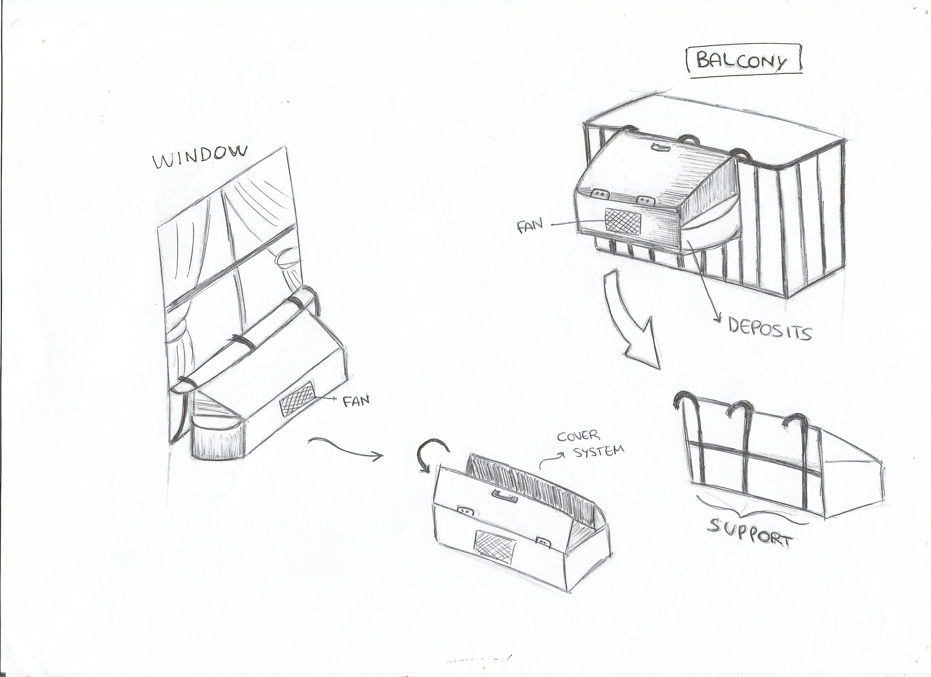
Structural drafts
</WRAP>
- Black box diagram 7.3.2.1 Black Box Diagram
- How does the numbering of the BibTex works?
- Should we upgrade the DokuWiki?

Minute
The leader of the meeting was Mathias. During this meeting we presented more precisely our idea with a cardboard scale model and how the greenhouse will work. The main problem that emerged was the cover and the self oriented point. Our solution is not a self oriented solution so we choose to be focus on our cover and improving it to bring more shadow to the plants. In an other hand coordinators gave us a feedback on the wiki to be careful with the bibliography and how to improve it.

5th Meeting (2017-03-23)

Agenda
- What is meant with the structural drawing? Is this in Solidworks?
- Can you put a link in an image on the wiki?

Minute
The leader of the meeting was Antonio. During this meeting, we presented our new idea because last meeting the coordinators found an issue with the door and the cover. So in the 5th week we thought to put two covers: one for winter season and one for summer season.
The winter cover is manual and transparent to let through the light needed for plant growth. The consumer can decide when he wants to put it, to cover the plants with cold temperatures and can leave it all winter. When spring arrives, it can remove the cover and store it at home.
The summer cover is attached to The GreenHouse and is automatic. It is activated thanks to sensors of rain and light to protect the plants. In this case the client does not need to take care of the protection. In this case, the system is more like a “shadow house”.
The issue with this idea was the storage of the winter cover. Our target are people who live in small flat so we have to think that maybe they can't store a cover.
Another part was mentioned during the meeting: we have to think of packing The GreenHouse and inserting a new chapter to the report on packaging and design.
Finally, we must start studying the sustainability part in order to choose the materials that we will use the best.

6th Meeting (2017-03-30)

Agenda
- Concerning the packaging, Is there a cutting table in ISEP to cut the blank of the boxes ?
- If yes, with which software it works (ArtiosCad, Picador)?
- If we decide to sell the product in kit, Should we make the final prototype in kit or already built?
- Is our division from the topics in State of Art and Project Development good?
- For the interim presentation, how we have to organise the power point ? How long should it last?

Minute
The leader of the meeting was Cristina. In this meeting the coordinators answered to our questions:
- Not particular tools available to the packaging part
- Not deliver the prototype in kit because it's too hard but we have to think about it for the report
- We will do a small scale packaging as prototype
- Think of another organisation of the state of the art
- Two slides for each topic: Marketing, Project management, Ethics and Sustainability, and then explain the beginning of our development

7th Meeting (2017-04-06)

Agenda
- Could you explain how and where we have to put the interim report? PDF and the insert? Or link?

Minute
The leader of the meeting was Christophe. During this meeting, the supervisors gave us a feedback on the list of materials. We talked about the best way to protect the wood of The GreenHouse. They answered to our questions.

8th Meeting (2017-04-27)

Agenda
- How works the assessment of the project (meeting, interim report/presentation, deliverables…) ?
- How much time will we get for the final presentation?
- In this presentation do we only present the development part or do we recapitulate what we did on the last one?
- What should we put on the poster?
- Discuss kit idea

Minute
The leader of the meeting was Alisson. During the meeting, the supervisors answered to our questions and we spoke about the kit. They suggested ideas to improve it.

9th Meeting (2017-05-04)

Agenda
- Feedback on the project development part
- When will we get our materials? Or when can we get them?

Minute
The leader of the meeting was Mathias. During this meeting, the supervisors help us with the list of material and gave us wood to avoid to buy it.

10th Meeting (2017-05-18)

Agenda

Minute
During this meeting, the team had no special question. The supervisors gave the material received and a point on what remains to be received was done.

11th Meeting (2017-05-25)

Agenda
- How will it work to get the tools and space needed to build and test the prototype?
- We think we got another motor then we asked, is this possible? Is there maybe a reason for this?
- With the final prototype, do we have to solder everything or can we use a little breadboard?
- What do we have to do with the materials list in the report? Do we update it and put the free things in it too?
- Should we make a list of materials for the final real product too and make a distinction?

Minute
The leader of the meeting was Cristina. During this meeting, the supervisors answer to our questions and give us more information to start to build the prototype.

12th Meeting (2017-06-01)

Agenda
- What do we have to have exactly for the deadline of Monday? Do we need to have performed all the test already?

Minute
The leader of the meeting was Antonio. The supervisors answered our question, which gave the team a better idea of the type of deliverables to download.

13th Meeting (2017-06-08)

Agenda
- When can we start soldering the electronics components? Should we prove that they work correctly first?

Minute
The leader of the meeting was Alisson. The supervisors gave us a feedback on the test part and gave us comments to improve them.

14th Meeting (2017-06-14)

Agenda
- What will be asked exactly in the personal interviews? Should we know every detail of the project?
- Could we get a small scale somewhere to perform a test?
- Could we get a big scale somewhere?

Minute
The leader of the meeting was Christophe.

Activities


